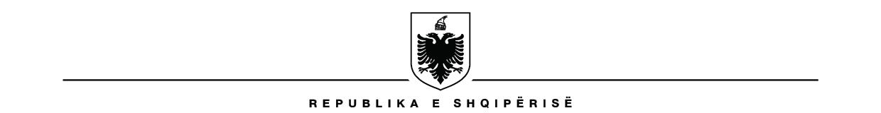

BASHKIA MEMALIAJ
KËSHILLI BASHKIAK

LISTA E KËSHILLTARVE

NR | EMËR | ATËSI | MBIEMËR | SUBJEKTI | LOGO | Numër telefoni | e-mail
1 | Asqeri | Hasan | Muçoima | PS |  | 0692295374 | asqerimucoima@yahoo.com
2 | Edmonda | Kalo | Harizi | PS |  | 0696420880 | edmondaharizi@gmail.com
3 | Afize | Agur | Sula | PS |  | 0682046767 | afizesula@outlook.com
4 | Anest | Tajar | Halili | PS |  | 0693414119 | hanest23@gmail.com
5 | Irena | Alem | Jaupi | PS |  | 0684055906 | jaupiirena@gmail.com
6 | Taulant | Novrus | Rama | PS |  | 0693929379 | ramataulant13@gmail.com
7 | Erjon | Bino | Sinanaj | PS |  | 0695292775 | erjonsinanaj730@yahoo.com
8 | Bujar | Xhevit | Mamaj | PSD |  | 0686235062 | bujarmama@gmail.com
9 | Petrit | Yzeir | Lumani | PDS |  | 0693691828 | petritlumani@ikloud.com
10 | Maltona | Hysen | Bërxhi | BF |  | 0696957347 | mberxhi@gmail.com
11 | Lauresha | Muharrem | Lila | BF |  | 0694246053 | laureshalila@icloud.com
12 | Flamur | Zenel | Mushamati | BF |  | 0684317512 | mushamatiflamur@gmail.com
13 | Xhevit | Nuri | Kacorri | PAA |  | 0692341238 | xhkacorri@shrfgj.al
14 | Esmerald | Luan | Xhemali | PD |  | 0672211603 | Xhemaliesmerald@gmail
15 | Arsola | Thimjo | Muzha | PD |  | 0692261855 | Muzhaarsola@yahoo

SEKRETAR KRYETAR
Erjola ALLKA Erjon SINANAJ

